VR251 Aesthetics
Art Docent Write-up
Pan Chongdan
516370910121
Jingan Sculpture Park
- Introduction
Jingan Sculpture Park is in the very center of Shanghai, and citizens can go to the park easily by underground. The park was built in 2007, as the only sculpture park in Shanghai downtown [1]. The creators of sculptures in the park are different artists, some of them even hold their own sculpture exhibitions in the park. However, the theme of the park is not only various sculptures but also nature landscapes including colorful flowers and grand lawn.
From my point of view, it conveys the idea of organic bond of urban city and nature beauty. In the crowd city center, the park is a good choice for people after tiring work to have a rest and enjoy the mixture of humanities art and nature beauty.
- Elemental Spring: Harmony (Water of Life)
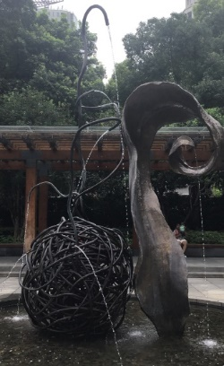
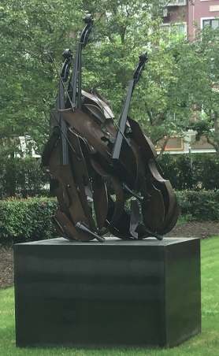
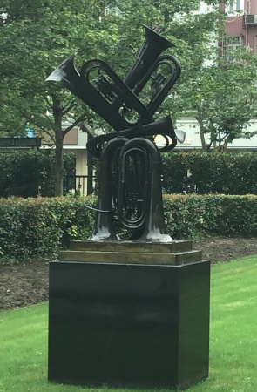
The first sculpture I saw in the park is called elemental spring: harmony, as known as Water of Life in Chinese. It’s located near the entrance of the park. The sculpture was created by Barbara Edelstein from New York. From my perspective, the left part looks like the root of a plant, while the right part looks like a leaf, and they’re connected by the moving element: water. the sculpture depicts the growth process of a plant and highlights water’s key role in it. The pool below the sculpture stands for the nature, which is the source of all life. Water and energy are drawn by the stem from the pool, and then the it moistens the leaves and comes back to the pool. The water has different routes and flows through different stems, its difference shows the plurality of natural. From my perspective, the sculpture imitates a harmonious and eternal natural process, and succeed in bringing me moving and multi-dimensional aesthetic experience, which is usually exclusive for nature itself. When I closed my eyes and listened to the sound of flowing water carefully, I could image the growth of all plants in the park, and felt the its great vitality. The sculpture expresses the idea that all creatures are keeping growing up and trying to coexist harmoniously in the world.
Figure 1. Elemental Spring: Harmony
Figure 2. Being Beauteous & Flon-Flon
- Being Beauteous & Flon-Flon
Being Beauteous and Flon-Flon are two of the musical sculptures in the park, created by Arman Pierre Fernandez from France. These sculptures are typical imitation artworks, depicting some specific instruments [2]. The characteristic of these sculptures lies in the arrangement of their objects, highlighting the feature of sounds of specific instruments visually. The violins look like to be interwind together while the trumpets are facing different directions. Violin’s music has various forms, and Being Beauteous also conveys a subtle feeling. Violin’s can be used to play lingering music, so the top of Being Beauteous emphasized the intertwine of different string. However, the scattered form of violins also implies little sorrow. On the other hand, the Flon-Flon is much more straight-forward. It looks like the trumpet are keeping moving up and down to play a magnificent music. To some extent, the sculptures also reflect the rhythm of people’s life. For citizens after work, Being Beauteous reminds them of their home and family, who’re waiting for them. The sorrow reflected from the sculpture makes them miss their home and want to be relaxed. However, when they see the Flon-Flon in the morning, it looks like the trumpets are urge them to work harder, and they may feel motivated.
- City Fantasy
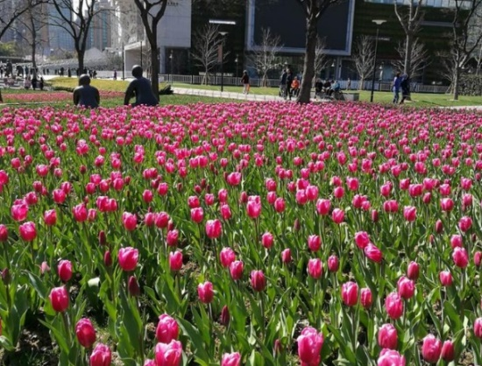
City fantasy is a sculpture showing the perfect fusion of natural beauty and humanities art, created by Joy Brown from U.S. It depicts some citizens sitting among sea of flowers and talk to each other peacefully and enjoy the nature beauty. When seeing this scenario, I also want to stop for a moment, to smell the scent of flowers and feel the cool breeze. The sculpture also reminds me of human’s relation with nature. The flowers will bloom or wither as times goes by, but the human-like sculptures always sit there. They stand for human’s greatness and capability of remaking nature and build grand cities. However, the sculptures are black, and it’s the colorful flowers and plants make the scenario beautiful. I think the artist is using the plants to imply that we need to live with the nature harmoniously so that we can have a better life.
Figure 3 City Fantasy
- Conclusion
All sculptures in the Jingan Sculpture Park have a unique and enchanting form. Most of them are very realistic and depicting common things in our life, but they’re usually arranged in an interesting and mysterious way. Although the sculptures are still, appreciator’s is stimulated to imagine the motion of the objects. When combined with moving natural elements like flowing water, they become different artworks, with both characters of natural beauty and humanities art. The artist’s design defines the form and theme of the sculpture, while the natural elements add uncertainty to it [3]. For example, when the flowers bloom or wither, the City Fantasy sculpture can give us different aesthetic experience. With the presence of nature, the framework is also broken, and the whole sculpture looks more vital. The creators are trying to share about their thoughts about city life with us through these sculptures, but I think they prefer us to generate our own thinking, especially after appreciating sculptures when natural elements are different.
- Reference
1. Official Account of Jingan Sculpture Park. http://mp.weixin.qq.com/mp/profile_ext?action=home&__biz=MzA3NTc2NDUwNw==&subscene=0#wechat_redirect
2. Noël Carroll: Philosophy of art, A contemporary introduction, Routledge 1999[J]. British journal of aesthetics, 2002, 42(2):211-214.
3. Hepburn, R.W. Contemporary aesthetics and the neglect of natural beauty. British Analytical Philosophy. 1996

